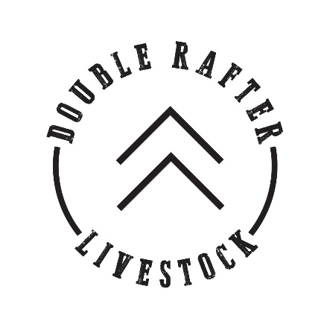

1411 Alford Rd.
Ellensburg, WA 98926 (509) 306-0205
DRLivestock@hotmail.com

Customer Name: Click here to enter text.
Phone: Click here to enter text.
Email: Click here to enter text.
Address: Click here to enter text.
City, State, Zip: Click here to enter text.

STEP 1:

VARIETY PACK

SELECT STEAKS
PACK
Choose Amount
CHECK A BOX

☐*QUARTER BEEF $4.75/lb
☐HALF BEEF $4.50/lb
☐WHOLE BEEF $4.25/lb
*Based on hanging weight
Ground Beef
Variety Pack is the onlyoption available for
Quarter Beef Purchase.
STEP 2:
*New York Steaks/
T-Bone Steaks
Rib Steaks
Top Sirloin Steaks Sirloin Tip Steak
Skirt Steaks
Cube Steaks
Arm Roasts
Flank Steak or
Tri Tip Roast
Chuck Roasts
Top Round Roasts Brisket
Short Ribs
Stew Meat
Soup Bones
☐New York Steaks OR
☐Tenderloin Steaks& T-Bone Steaks
Rib Steaks
Top Sirloin Steaks
Flank Steak
Tri Tip Roast

Remaining cuts will be
processed into high quality, lean ground beef
Choose Package
CHECK A BOX
☐VARIETY PACK

☐SELECT STEAK PACK
☐CUSTOMIZED PACK
CUSTOM PACK- YOU PICK
Check the cuts you DO NOT WANT and these cuts will be
processed into high quality, lean ground beef.
STEP 3:
Choose Packaging
CHECK A BOX

GROUND BEEF
☐1 lb pkg ☐2 lb pkg
Steaks 1" thick, packaged 2/pack
Roasts 3-4 lbs. each
☐New York Steaks ☐T-Bone Steaks
☐Rib Steaks
☐ Top Sirloin ☐ Steaks
☐ Sirloin Tip
☐ Steak
☐ Flank
☐ Tri Tip Roast
☐ Skirt Steaks
☐ Cube Steak
☐ Arm Roasts
☐ Chuck Roasts
☐ Top Round
☐ Roasts Brisket
☐ Short Ribs
☐ Stew Meat
☐ Soup Bones
Ground Beef

You pick up! Inquire about meeting options if needed
Please check each box below and sign to show that you have read and agree to the following statements:
☐ I have reviewed my order and understand that once I send it in changes cannot be made.
☐ I understand that hanging weights of whole, half, and quarter orders may vary. I agree to pay per pound depending on
the final hanging weight of my order.
☐ After the $100 retaining fee is submitted, no refunds will be issued. A lot of work and time goes into finishing
your beef and planning butcher accommodations.This fee will be deducted from your final balance.
☐ Meat cannot be resold.

Click here to enter text. Click here to enter text.
Signature Date
SAVE and email form to DRLivestock@hotmail.com or mail to address address above.
Call Casi Watterson with any questions at (509) 306-0205

